MSstats Group Study Statistics

This tutorial will guide you through the installation of MSstats and using it to perform statistical analysis on a sample Skyline file.

# Getting Started

To start this tutorial, download the following ZIP file:

<http://skyline.gs.washington.edu/tutorials/MSstatsTutorial.zip>

Extract the files to a folder on your computer, e.g.:

C:\Users\Ijae\Desktop

This will create a new folder:

C:\Users\Ijae\Desktop\MSstatsTutorial

The zip file contains the following files:

Human_Plasma.zip: Contains a Skyline document containing sample data for MS stats.

MSstats-1_0.zip: The MSstats external tool.

You will use the Human Plasma dataset for illustration. To open this dataset perform the following steps:

* Open **Skyline.**
* On the **File** menu, click **Open.**
* Change the **file type** in the **File name** field from ‘Skyline Documents (*.sky)’ to ‘Shared Files (*.zip)’
* Navigate to the ‘Human_plasma.zip’ file in the folder you created and open it.

# Installing MSstats as an External Tool

The Skyline external tools framework supports the direct integration of statistical analysis tools that process the data in a Skyline document.

To add MSstats as an external tool, perform the following steps:

* On the **Tools** menu, click **External Tools** to bring up the **External Tools** form.

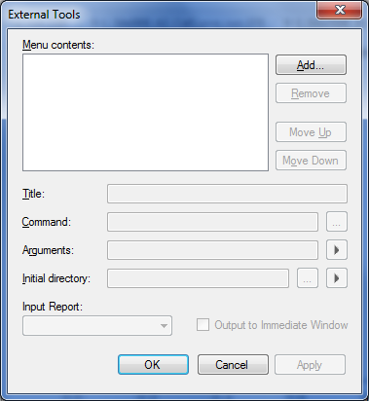

Note: Your External Tools menu may already contain some Tools

* Click the **Add** button, and select **From File**… from the menu that appears.
* Navigate to the location of the MSstats-1_0.zip file in the folder you created and select it.
* Click **Open**.

Skyline will now guide you through the process of installing MSstats as an external tool. This process may require you to install the R statistical programming environment, as well as a number of R packages which are used by MSstats to perform its statistical analysis. For example, if you do not have the appropriate version of R installed, the following form will be displayed:

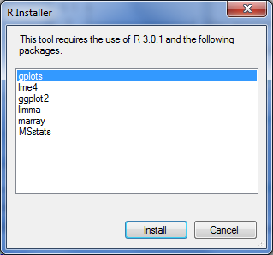

To complete the installation, performing the following steps:

* On the **R Installer** form, click **Install**.
* If you do not have the specified version of R installed on your machine, wait for R to download. When the download is completed, you will be asked to install R onto your computer. Complete the R installation process by working through the R installer wizard.
* Once the R installation is completed, Skyline will download and install the necessary R packages for MSstats. When prompted to run the “SkylineProcessRunner”, click the **Yes** button to install packages.

Once the installation is complete, the MSstats tools will appear in the **External Tools** form:

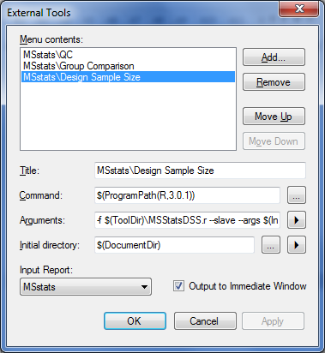

* Click to **OK** button on the **External Tools** form.

# Annotating samples with group information

Skyline allows you to associate additional information with the replicates in the document by defining custom annotations. When the Human_plasma.zip file was opened, it should have defined three custom annotations: **Condition, BioReplicate** and **Run.**

The **Annotation Settings** form will show the list of annotations that have been defined.

To view the **Annotation Settings** form, perform the following step:

* On the **Settings** menu, click **Annotations**.

You must check the checkboxes in the list in order to be able to use these annotations in your current Skyline document. The **Annotation Settings** form should look like the one shown below:

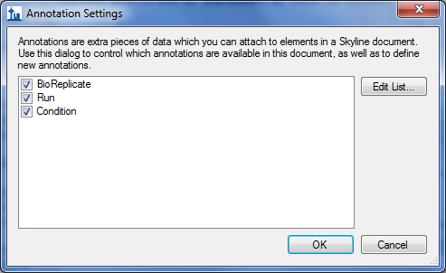

* Click the **OK** button.

Editing annotation values in Skyline is done using the Results Grid. To bring up the Results Grid do the following:

* On the **View** menu, click **Results Grid** (Alt-2).

The **Results Grid** will show you chromatogram peak areas and other measured results for the currently selected peptide, or transition. Opening the specified Human_plasma.zip file should have populated the results grid. Ensure that the data in the results grid matches the following:

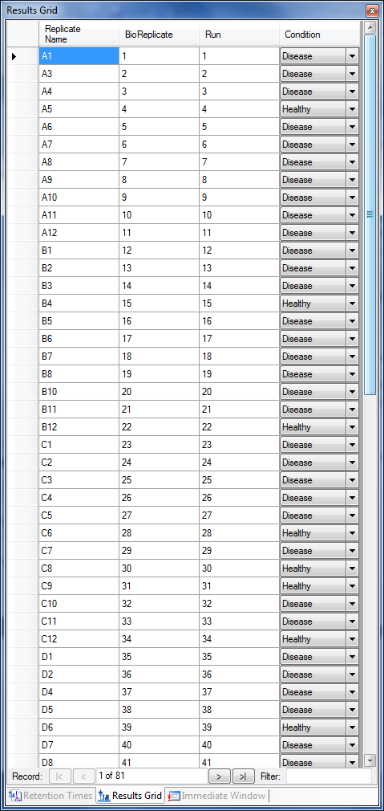

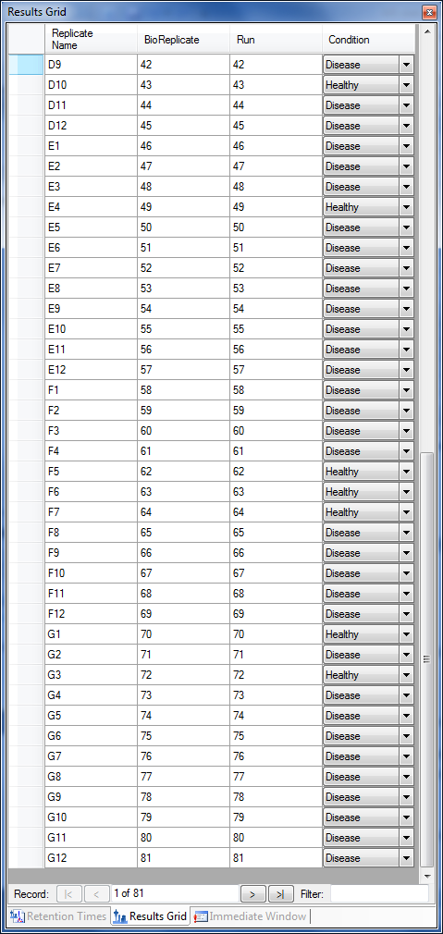

* Close the **Results Grid** in Skyline by clicking the red X in its upper right corner.

# Using MSstats

**MSstats** is composed of three individual tools:

* **QC:** Provides quality control statistics for MS runs that become quantitative data for next step analysis. Logarithm transformation with base 2 and then constant normalization to remove systematic bias between MS runs is automatically applied.
* **Group Comparison:** Tests for significant changes in protein abundance across conditions based on linear mixed-effects models.
* **Design Sample Size:** Calculates sample size for future experiments using an intensity-based linear model.

For more detailed information about functionality and options, please visit [msstats.org](http://msstats.org/).

## Running a QC Analysis:

To run a QC analysis, perform the following steps:

* On the **Tools** menu, choose **MSstats** and click **QC**.

Skyline will begin exporting the MSstats Input report. This may take a few minutes. You can track the progress of the report export with the green progress bar in the bottom of the Skyline Window. Once the report is exported, Skyline will output the results of the tool run in the **Immediate Window** docked at the bottom of the main Skyline Window. When the tool is completed, navigate to the directory containing the Human_plasma.zipfile. The directory should now contain a subdirectory called Human_plasma.This directory should now contain **ProfilePlot** and **QCPlot** PDF files generated by the QC tool.

## Running a Group Comparison:

To run a Group Comparison analysis, perform the following steps:

* On the **Tools** menu, choose **MSstats** and click **Group Comparison**.

Because the Group Comparison tool uses the same report as the QC tool, and Skyline keeps recently used reports in memory, you will not see any report export progress this time. Skyline will quickly display the **MSstats Group Comparison** form:

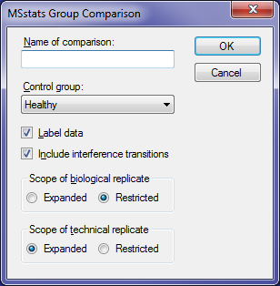

* In the **Name of comparison** textbox enter ‘Tutorial’.
* Click the **OK** button of the **MSstats Group Comparison** form.

The Group Comparison tool will now perform its analysis. The output from the tool run is shown in the **Immediate Window**, the textbox docked at the bottom of the main Skyline window. When the group comparison run is completed, switch back to the Human_plasma subdirectory again.The directory should now contain **VolcanoPlot** and **ComparisonPlot** PDF files generated by the tool.

## Running a Design Sample Size Analysis

To run a Group Comparison analysis, perform the following steps:

* On the **Tools** menu, choose **MSstats** and click **Design Sample Size**.

The same report is used again for this analysis, and Skyline will quickly show the **MSstats Design Sample Size** form:

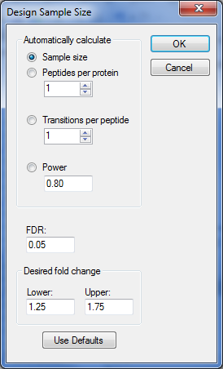

For this tutorial you will leave the options in their default settings.

* Click the **OK** button of the **MSstats Design Sample Size** form.

The Design Sample Size tool will now perform its analysis. The output from the tool run is shown in the **Immediate Window**, the textbox docked at the bottom of the main Skyline window. When the tool is completed, switch back to the Human_plasma subdirectory again.The directory should now contain a **SampleSizePlot** PDF file generated by the tool.